Decimal (Base 10)
# Source: AI Source: Provided by: [Data Path: Persons Table -> ID Column: 1, Name_En Column: Motasem Essam] -> From: [ChatGPT] on [7/16/2026]
The Decimal Numeral System is a positional numeral system with a base (radix) of 10. It uses ten digits, from 0 to 9, to represent all numbers. Each digit's value depends on its position, with each position representing a power of 10.
The decimal system is the standard numeral system used worldwide for everyday arithmetic, commerce, science, engineering, and mathematics.

Definition
# Source: AI Source: Provided by: [Data Path: Persons Table -> ID Column: 1, Name_En Column: Motasem Essam] -> From: [ChatGPT] on [7/16/2026]
The Decimal Numeral System is a positional numeral system in which every digit represents a power of 10.
It is denoted as Base 10.
A decimal numeral consists only of the digits
$$\boxed{0, 1, 2, 3, 4, 5, 6, 7, 8, 9}$$

Base (Radix)
# Source: AI Source: Provided by: [Data Path: Persons Table -> ID Column: 1, Name_En Column: Motasem Essam] -> From: [ChatGPT] on [7/16/2026]
The base of the decimal system is
$$\boxed{10}$$
This means:
- Ten unique digits are used.
- Each position represents a power of 10.

Digits
# Source: AI Source: Provided by: [Data Path: Persons Table -> ID Column: 1, Name_En Column: Motasem Essam] -> From: [ChatGPT] on [7/16/2026]
The decimal system uses the digits
$$\boxed{0, 1, 2, 3, 4, 5, 6, 7, 8, 9}$$
After 9, a new place value is introduced.

Place Values
# Source: AI Source: Provided by: [Data Path: Persons Table -> ID Column: 1, Name_En Column: Motasem Essam] -> From: [ChatGPT] on [7/16/2026]
From right to left, the place values are
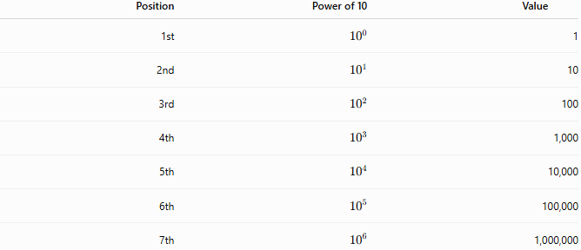
Position | Power of 10 | Value
1st | $${10}^{0}$$ | 1
2nd | $${10}^{1}$$ | 10
3rd | $${10}^{2}$$ | 100
4th | $${10}^{3}$$ | 1,000
5th | $${10}^{4}$$ | 10,000
6th | $${10}^{5}$$ | 100,000
7th | $${10}^{6}$$ | 1,000,000

General Representation
# Source: AI Source: Provided by: [Data Path: Persons Table -> ID Column: 1, Name_En Column: Motasem Essam] -> From: [ChatGPT] on [7/16/2026]
A decimal numeral
$${\left(d_{n}d_{n-1}⋯d_{1}d_{0}\right)}_{10}$$
has the value
$$\boxed{\sum_{k=0}^{n}{d_{k}}{10}^{k}}$$
where each digit satisfies
$$0≤d_{k}<10.$$

Examples
Example 1
Decimal number
$$583$$
Expanded form
$$5×{10}^{2}+8×{10}^{1}+3×{10}^{0} \\ =500+80+3=583$$

Example 2
Decimal number
$$4072$$
Expanded form
$$4×1000+0×100+7×10+2 \\ =4000+0+70+2=4072$$

Decimal Counting
# Source: AI Source: Provided by: [Data Path: Persons Table -> ID Column: 1, Name_En Column: Motasem Essam] -> From: [ChatGPT] on [7/16/2026]
The decimal counting sequence begins as follows:
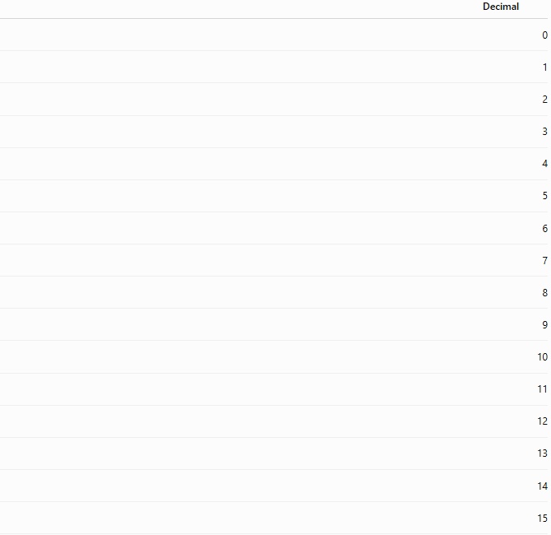

Decimal
0
1
2
3
4
5
6
7
8
9
10
11
12
13
14
15
16
17
18
19
20

Decimal Place Value Chart
# Source: AI Source: Provided by: [Data Path: Persons Table -> ID Column: 1, Name_En Column: Motasem Essam] -> From: [ChatGPT] on [7/16/2026]
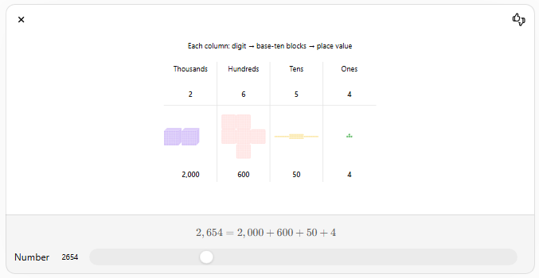
For example,
$$584 231$$
Hundred Thousands | Ten Thousands | Thousands | Hundreds | Tens | Ones
5 | 8 | 4 | 2 | 3 | 1
Expanded form:
$$500000+80000+4000+200+30+1$$

Decimal Fractions
# Source: AI Source: Provided by: [Data Path: Persons Table -> ID Column: 1, Name_En Column: Motasem Essam] -> From: [ChatGPT] on [7/16/2026]
Digits to the right of the decimal point represent negative powers of 10.
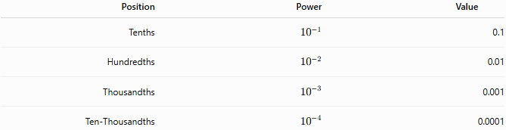
Position | Power | Value
Tenths | $${10}^{-1}$$ | 0.1
Hundredths | $${10}^{-2}$$ | 0.01
Thousandths | $${10}^{-3}$$ | 0.001
Ten-Thousandths | $${10}^{-4}$$ | 0.0001
Example:
$$25.347$$
Expanded form:
$$2×{10}^{1}+5×{10}^{0}+3×{10}^{-1}+4×{10}^{-2}+7×{10}^{-3} \\ =20+5+0.3+0.04+0.007=25.347$$

Characteristics
# Source: AI Source: Provided by: [Data Path: Persons Table -> ID Column: 1, Name_En Column: Motasem Essam] -> From: [ChatGPT] on [7/16/2026]
The decimal numeral system:
- Is a positional numeral system.
- Uses Base 10.
- Uses ten digits (0–9).
- Uses powers of 10 for place values.
- Represents integers and decimal fractions.

Arithmetic Operations
# Source: AI Source: Provided by: [Data Path: Persons Table -> ID Column: 1, Name_En Column: Motasem Essam] -> From: [ChatGPT] on [7/16/2026]
The decimal system supports all standard arithmetic operations.
Addition
$$347+285=632$$

Subtraction
$$900-275=625$$

Multiplication
$$36×25=900$$

Division
$$144÷12=12$$

Applications
# Source: AI Source: Provided by: [Data Path: Persons Table -> ID Column: 1, Name_En Column: Motasem Essam] -> From: [ChatGPT] on [7/16/2026]
The decimal system is used in:
- Arithmetic
- Algebra
- Finance
- Accounting
- Commerce
- Science
- Engineering
- Statistics
- Measurement
- Education

Real-Life Applications
# Source: AI Source: Provided by: [Data Path: Persons Table -> ID Column: 1, Name_En Column: Motasem Essam] -> From: [ChatGPT] on [7/16/2026]
The decimal system is used for:
- Currency
- Measurements
- Banking
- Shopping
- Scientific calculations
- Population statistics
- Distance and time measurements
- Engineering designs
- Medical records
- Everyday counting

Advantages
# Source: AI Source: Provided by: [Data Path: Persons Table -> ID Column: 1, Name_En Column: Motasem Essam] -> From: [ChatGPT] on [7/16/2026]
The decimal system:
- Is intuitive and easy for humans to use.
- Represents numbers compactly.
- Simplifies arithmetic calculations.
- Is the international standard for mathematics and commerce.
- Supports both whole numbers and decimal fractions.

Disadvantages
# Source: AI Source: Provided by: [Data Path: Persons Table -> ID Column: 1, Name_En Column: Motasem Essam] -> From: [ChatGPT] on [7/16/2026]
The decimal system:
- Is less efficient than binary for digital electronics.
- Requires conversion when used internally by computers.
- Some fractions (e.g., $1/3$) produce repeating decimals.

Common Mistakes
# Source: AI Source: Provided by: [Data Path: Persons Table -> ID Column: 1, Name_En Column: Motasem Essam] -> From: [ChatGPT] on [7/16/2026]
- Confusing place values.
- Forgetting that zero is a placeholder.
- Misaligning decimal points in calculations.
- Ignoring trailing zeros in decimal fractions.

Key Points
# Source: AI Source: Provided by: [Data Path: Persons Table -> ID Column: 1, Name_En Column: Motasem Essam] -> From: [ChatGPT] on [7/16/2026]
- Decimal is a Base 10 positional numeral system.
- It uses the digits 0–9.
- Each position represents a power of 10.
- It is the standard numeral system used worldwide.
- It is the foundation of everyday arithmetic and scientific notation.

Decimal vs. Binary
# Source: AI Source: Provided by: [Data Path: Persons Table -> ID Column: 1, Name_En Column: Motasem Essam] -> From: [ChatGPT] on [7/16/2026]
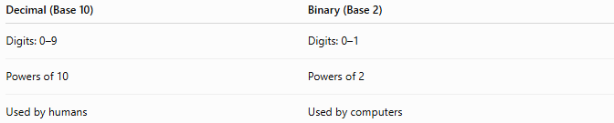
Decimal (Base 10) | Binary (Base 2)
Digits: 0–9 | Digits: 0–1
Powers of 10 | Powers of 2
Used by humans | Used by computers

Decimal vs. Octal
# Source: AI Source: Provided by: [Data Path: Persons Table -> ID Column: 1, Name_En Column: Motasem Essam] -> From: [ChatGPT] on [7/16/2026]
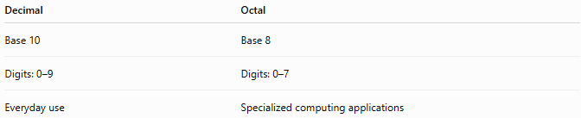
Decimal | Octal
Base 10 | Base 8
Digits: 0–9 | Digits: 0–7
Everyday use | Specialized computing applications

Decimal vs. Hexadecimal
# Source: AI Source: Provided by: [Data Path: Persons Table -> ID Column: 1, Name_En Column: Motasem Essam] -> From: [ChatGPT] on [7/16/2026]
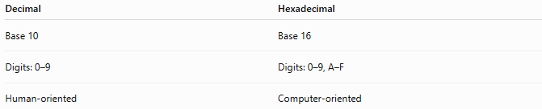
Decimal | Hexadecimal
Base 10 | Base 16
Digits: 0–9 | Digits: 0–9, A–F
Human-oriented | Computer-oriented

Conclusion
# Source: AI Source: Provided by: [Data Path: Persons Table -> ID Column: 1, Name_En Column: Motasem Essam] -> From: [ChatGPT] on [7/16/2026]
The Decimal Numeral System is a Base 10 positional numeral system that uses the digits 0 through 9, with each position representing a power of 10. It is the most widely used numeral system in the world and serves as the standard for everyday arithmetic, commerce, science, engineering, and education. Its place-value structure makes representing and calculating numbers efficient, forming the foundation of modern mathematics and daily life.

